**NAME: OGUNDIPE HASSAN PELUMI**

**MATRIC NO: 207115**

**FACULTY: SCIENCE**

**DEPARTMENT: ARCHAEOLOGY**

**TELEPHONE NO: +2349030749485**

**COURSE CODE: ARC 213**

**LEVEL: 200**

**COURSE TITLE: INTRODUCTION TO MUSEUOLOGY**

**LECTURER-IN-CHARGE: DR. OPADEJI.**

**ASSIGNMENT: THE ORGANISATIONAL STRUCTURE, DEPARTMENT IN THE MESEUM AND THEIR FUNCTIONS.**

**ABOUT THE MUSEUM.**

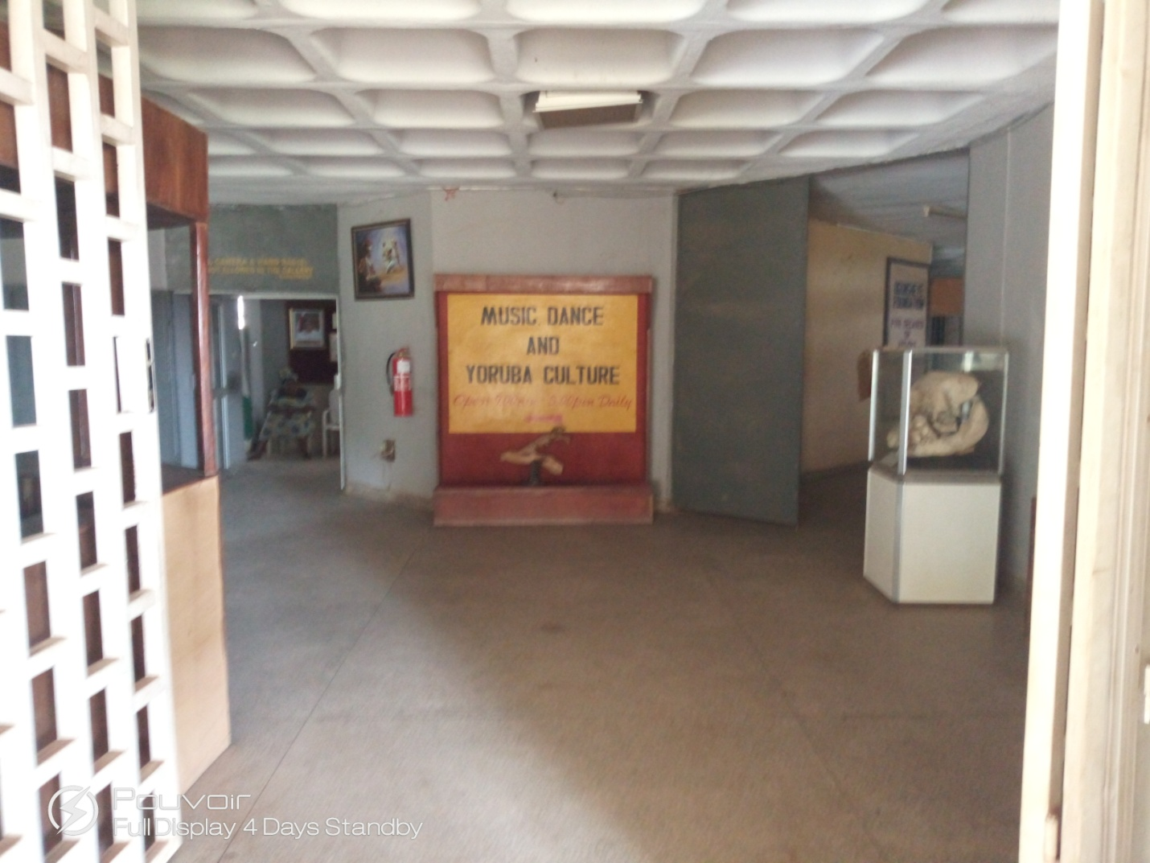

The museum of national unity is one of the four museums that is projected by Yakubu Gowon during his government after the civil war to enhance unity within Nigeria.

The museums consist of a lot of archaeological excavations that are found in some specific part of Nigeria. It also consists of musical instruments, stone age tools, material remain, relics and so on.

The museum has four exhibit galleries and they are;

1. The Unity gallery
2. The masquerade gallery
3. The pottery gallery
4. The Yoruba gallery

**EXHIBITION IN THE UNITY GALLERY**

Someone might say that this is the heart of the museum because it’s unity gallery, which stands for what the whole museum is all about.

In this part of the museums, it comprises musical instruments, this tells us how important musical instruments are because those musical instruments have effect on our fore father lives and brings them together which are used by our fore fathers. We were showed some interesting musical instruments.

Mrs adedeji R.A, who was from the education department led the tour and started by showing us the musical instruments, she showed us idiophones (a self sounding musical instrument, because it produces sound by its vibration without strings or membrane.) and were also showed a bell gong which is also known as “ogene” by igbos and Agogo by Yoruba.

Mrs adedeji R.A continues by showing us xylophone which is made from animal horn, feather, stick and twine. It is uniquely familiar to the modern piano.

We also saw chordophones, which looks just like guitar. It contains the chords just like normal guitar.

We went ahead to see some shakers, that are called shekere in Yoruba and the igbo shakers are tied around their waste, arms and neck while dancing.

After then, we proceed to where the drums are, and these drums comprise different Yoruba drums. They contain the Gan Gan,the bata, and also saworo ide which is also a double headed drum.

She moved on by telling us about the purposes of drums. she talked about the fact that, drums are used for ceremonial or ritual process. She showed us some ritual drums, the drums are beating by different people with different reasons. For exame, we saw a drum beating for people looking for the fruit of labour, while the second is beating by impotent man, the third and the fourth are found the esu and obatala shrine respectively.

This shows the fact that; the drums are used for different purposes, most especially the ritual ones, while the ceremonial drums are for the purpose of enjoyment.

The next set of drums we were shown contains drums from the different ethnic groups of Nigeria. The names of the drums are Ganga (it’s a talking drum that is originated from Hausa land.), the heavy drums called Agba(it is found among the urchoboin Delta state), another drum that we have on this same collection is Gin-who from adamawa, it’s also a talking drum, galango drum from the Hausa, the igba drum from igbo.

We were then shown the Agere drum used for naming, wedding and burial ceremonies among the hunters, and that’s why it’s called “hunter’s drum”. We also saw the ogboni drum found in the ogboni shrine.

**THE MASQUARADES GALLERY**

In the masquerades we were shown some beautiful set of masquerades from Igbo, Yoruba, and Hausa ethnics group. The first set was the Igbo masquerade which comes in pair, the male and the female. The male is called ekpe masquerades while the female is called Agboghommo. We saw another Igbo masquerade which is amikwo masquerade and Nkwa masquerade. It is commonly called Ojuju calabar, it has a bell at its back which makes sound while it walks and dance and a stick on its hand.

The second set of masquerade was the Hausa masquerade called Dodo in Hausa. It is not so sophisticated and a light masquerade they perform different display and dances a lot while performing.

The next masquerade we saw was the Yoruba masquerade, this includes egungun oja that comes out annually at the king’s market (Oja Oba). According to the woman this celebration is to mark end the era of slavery. We also saw the Gwari masquerade belonging to the people of Gwari, located in Abuja.

**THE POTTERY GALLERY**

The pottery gallery was well stocked with the fire ceramics mostly Yoruba potteries. The woman took us to the first and the pictorial part which displays the transition of pots from the process of harvesting to its final location in the market; it simply displays the transition of the pots.

The pots are grouped into;

DOMESTIC GROUP.

This includes pots for domestic uses like;

1. Water pots for fetching water.

2. The save, an oval pots used for saving money

3. The cooking pots that comes in different shape and sizes.

4. The clay plate for dishing.

5. Basin for washing hands and keeping disposable material.

6. The beakers.

PERFORATED POTS

This is a coal pots that is used for generating heat for cooking, the sieve is for draining water out of materials especially food stuff and a pot for smoking fishes, meat and other materials.

THE FRYING POTs

This point is mainly used for frying cassava flacks, which is locally called Garri.

THE RITUAL POTS.

These are the type of pots that are usually found in the shrine. They vary in size depending on their functions. Some are used for concoction while some are used for keeping charms.

STORAGE POTS.

These are type of pots used for storing things, for example Amu, this is a pots used for storing water, and it cools the water to some extent. And there is another one called Kolo, which is used for saving money.

CEREMONIAL POTS

The first we saw was the widow pot which is bought for the widow to keep the memory of her late husband so as to prevent her from marrying another man.

**THE YORUBA GALLERY**

At the Yoruba gallery the first set of display shown to us was stone age tools using for cutting, making fire, toothpicks and shaping other tools. Next to this is the display of the archaeological recoveries from ile ife and iwo eleru man. Another exhibition at the Yoruba gallery was that of the ogboni a secret cult among the Yoruba.

Another section of the Yoruba gallery displays beautiful regalia of Oba Abimbola from ijebu remo. The king was the first to wear a beaded clothes and crown. His staff, as well as his small crown was also on display.

The next session was the material used in consulting the ifa deity, the Ogun shrine and the materials for worshiping Ogun. There was also Osanyi deity, who is like a nurse, the orisha oko who is the gods of agriculture, the Sango shrine and lastly the orisha ibeji.

The last part of the gallery was the Baba blacksmith also known as Baba alagbede blowing his little furnace and some of his finished materials were beside him. Opposite that is the Baba ogedegbe and his guns, Baba ogedegbe is said to be a warrior.

We have the tie and dye next to it, it process and its product, we also have the aso oke stand, and this displays a man weaving the aso oke, with some beautiful ones right next to him.

**THE ORGANISATIONAL STRUCTURE, DEPARTMENT IN THE MESEUM AND THEIR FUNCTIONS.**

During our visit to the museum I was able to see and be in touch with only one person from a department, which is the education department. As a visitor, in most cases I’m bound to meet only people from the education department.

**EDUCATION DEPARTMENT**

This is one of the most influential, and the most important part of a museum, it’s a point of contact between the museum and the visitors. People from the museum has to be properly trained, because they interpret the materials in the museum, so if they are not properly trained, there won’t be proper exhibition that is, visitors will not really see the beauty, that is, story behind each of the materials in the museum. In my case because the woman taking us on the tour Mrs adedeji R.A, knew a lot about the material she was showing us, we were able to understand her and the materials even better.

**ADMINISTRATOR.**

The administrator comprises the board and the curator. The work of the board is to deliberate and decide on the affairs of the museum, in some small museum there might not be a board, because they are not really important to them, all the work is being done by the curator. So, in a big museum there is need for a board, because the curator cannot decide on his own, the curator needs order from the board. Apart from receiving order from the admin, the curator has a great impact in the affairs of a museum. After the admin has decided, the curator takes the advice, the curator do the remaining heavy lifting. And that includes the staffing of the museum. Because he can oversee everything in the museum, he has to put some people in charge of something, so the curator staff workers.

In conclusion the active and inactive of the museum depends on the curator. They are the greatest factor that determines the activity and the inactivity of the museum, and during the visit, the education department did well by giving us a clear knowledge and story behind the materials in the museum.